The Fall of Constantinople: Establishing Ottoman Imperium

Chase D. Kramer

Arch 598-2

When Ottoman Sultan Mehmed II captured the city of Constantinople, he, at least in his mind, culminated the Ottoman dream of inheriting the Byzantine Empire by capturing its capital city. For three days Mehmed II allowed his troops to pillage and plunder the treasures and remaining inhabitants of the city, decreeing as he stopped a Turk smashing a marble slab of the Hagia Sophia “The treasure and enslavement suffice for you [his troops]. The buildings of the city belong to me.” From the very first moment of capture, it was apparent that the sultan knew the fabric of Constantinople – its architecture already a symbol of imperial power – would play a crucial role in furthering the image and strength of the Ottoman Empire. Eventually, the transformation of the city into an Ottoman capital would eventually help to usher in an Ottoman Golden Age of conquest, culture, and imperial might. However, it was not the Sultan’s role alone that eventually established Ottoman imperium; it was his ability to capitalize on the specific geographic history and legacy of the Ottomans – “context”, his personal cosmopolitan interests and inclination toward western inspiration – “agency”, as well as the specific building programs that provided a “catalyst” for conversion of Constantinople into the new Ottoman capital.

Notions of Empire: Conquest and Legacy
The notion of “place” has always played an important role in the understanding of empire in the history of Constantinople, now modern day Istanbul, Turkey. Though supposedly having originated near the intersection of China, Mongolia, and Russia, the Turkish people that settled in Anatolia formed the Rum Selçuk empire (later distinguished from the whole of the Great Selçuk empire) eventually saw themselves as having a direct mystical lineage between their empire and Rome (from which rum is derived). The historic legacy of Anatolia was more than apparent to the Turks, the land having been under rule of such civilizations as the Persians, Ancient Greece, Rome and Byzantium, as well as the Sassanids and Omayyads. However, the Selçuks of this area chose to identify themselves distinctly from any Persian heritage, and rather associate themselves with a western (in orientation, not necessarily culture) perspective and legacy, that of Rúm or Ancient Rome. In fact, part of the success of the Selçuks can be attributed to their familiarity and adoption of former Roman or Byzantine structures and places. In 1097, the city of Konya, once surrounded by a circular wall built by Justinian, became the capital of Konya and was later furnished with a similar wall. Other cities (where walls still exist) show Byzantine and Selçuk construction intermingled.
With the pressures of the Mongols pushing from the east and the eventual collapse of the Selçuk Dynasty into a series of Turkish Beyliks (or emirates), the tribe of Osman (the Ottomans) emerged as the preeminent power in northwest Anatolia. It was the Ottomans who would focus more attention on a conquest for establishing, once and for all, a Byzantine legacy connected to the Turks. Inheriting a “spatial” tradition from the Selçuks, the Ottomans launched a campaign of attrition on the Byzantine Empire, constantly conquering surrounding lands and then relocating their capital first in Bursa (south of the Byzantine capital), then Edirne (north of the capital), slowly gnawing away at the perimeter of the Byzantine Empire until it was reduced to a single, key city: Constantinople.
However, the Ottoman focus on conquering the Byzantine Empire was part of a larger system of imaging for the young empire. The developments in Ottoman architecture prior to the eventual capture of Constantinople represent a shift in attitude about what architecture communicates, specifically on a monumental and imperial scale. Granted, there is evidence of this shift even before the emergence of the Ottomans. Looking back to the Selçuk adoption of Romano-Byzantine space, the city of Kayseri (or Roman Caesarea) represents a massive scale of building (citadel and walls reminiscent of Romano-Byzantine defense and siege fortifications) that still lends itself to a monumental and “impregnable air.”
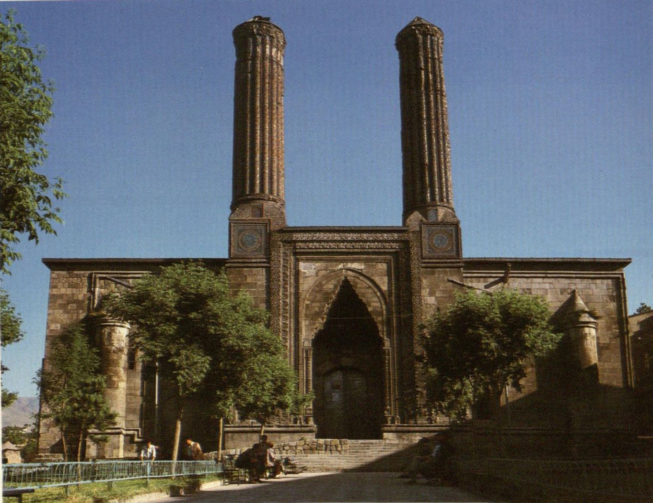
On a less militaristic note, the Ottomans (and even the Selçuks before them) were beginning to utilize the power of Islam to also establish their legitimacy as an empire. The madrasa (or Koranic school) was a building type that, though a staple of Mamluk architecture south of the Selçuk territories, was being reinterpreted by the earliest Selçuk architects. The madrasa played a crucial role in developing the success of the Rum Selçuk Empire as a perhaps a “new” center for religious enlightenment that rivaled others throughout the Islamic world, and, as a form that affirmed the Sunni faith, “no expense was too great and no embellishment too lavish.” The result was authoritative structures like that of the Çifte Minare Medresesi in Erzurum and the later Çifte Minare in Sivas (See Figure 1) . Later, the Ottomans combined the authoritative power of the madrasa with the developing symbol of the mosque and created a new form of urban complex called a külliye. Though building a mosque interconnected with a madrasa was nothing new in Islamic architecture, the külliye introduced other public buildings into the program, including a hospital, library, asylum, baths, and alms-kitchen, essentially creating a small independent community within the city.
Figure 1: Çifte Minare Medresesi in Erzurum
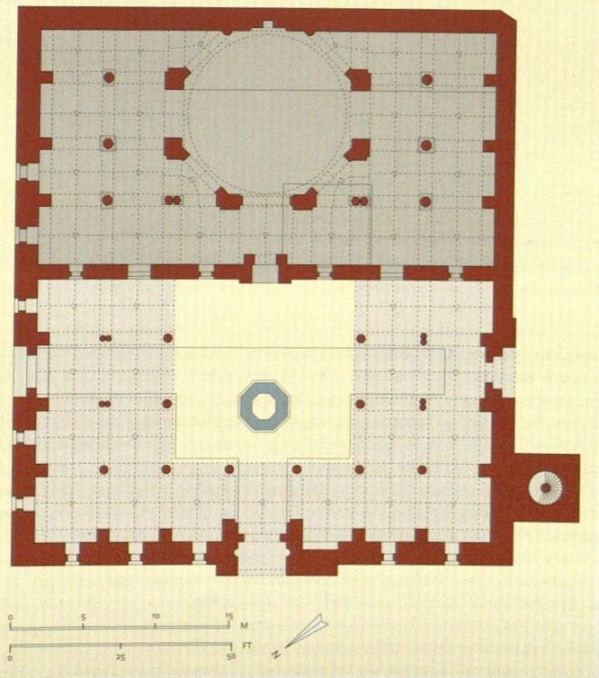
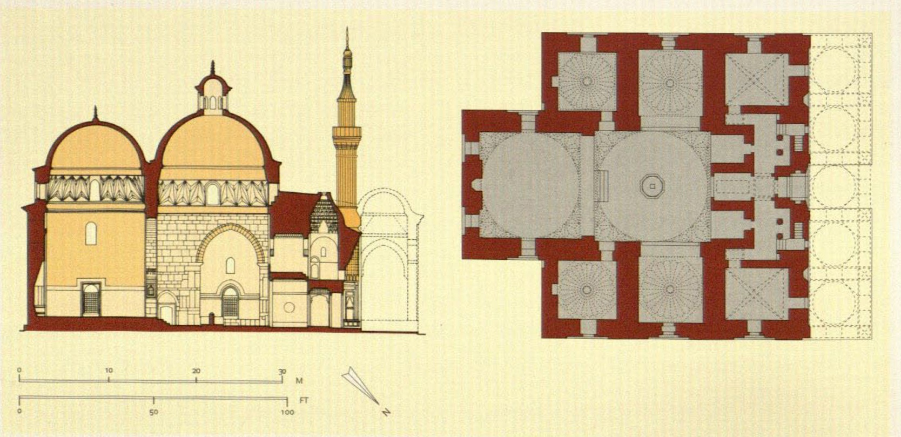
As already hinted at, the mosque itself was undergoing certain changes that lent itself to an image of symbolism and monumentality, rather than simply a functional space. In search of new architectural solutions, the Ottomans abandoned the traditional hypostyle prayer hall found in many mosques up until this period. Instead, the prayer-hall began to take on a very individual form utilizing Byantine-like domes placed one behind the other (serving as the prominent silhouette for mosques until the Ottoman capture of Constantinople), thus created an inverted T shape very different and unique from the typical oblong Arab plan (see Figure 2) . This longitudinal form was more akin to the model of Byzantine Christian churches, almost as if the architecture was trying to communicate the legacy the Ottoman Empire envisioned for themselves. Even truer to this analogy, some Ottoman mosques include a sultan’s loge, enclosing and elevating the sultan in a similar manner as imperial loggia of a Byzantine church where the monarchs sat while Mass was celebrated.
Figure 2: Comparison of The Green Mosaue in Bursa, 1420 (Left) and Great Mosque at Manisa, 1366.
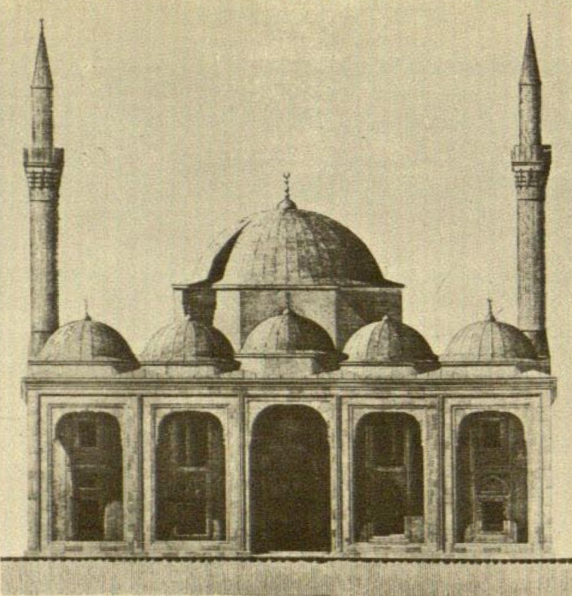
Most unique about the developing form of the mosque, however, was that, like the lofty yet imposing Gothic cathedrals of Western Europe, the mosque began to be seen as an object of beauty and power, rather than simply a gathering space. At the Beyazid Mosque in Bursa, conscious effort was put into lessening the overbearing and massive impression of the entrance while simultaneously balancing an impression of monumentality with simplicity and precise proportions (see Figure 3). Furthermore, the Beyazid Mosque has a strong emphasis on the beauty of the building material itself – “gray, finely grained limestone” – and on the precision of its construction.
Ultimately, however, the Selçuk and Ottoman changes and reinterpretations of Islamic and Byzantine forms (as well as the fusion of both) were more about formal and spatial experiments, as architects searched for a truly unique or Ottoman style. They had not quite yet reached a mature, classical style. That would come only with the adoption of an imperial style echoed by the goals of the Fatih and the subsequent re-imaging of Constantinople, essentially ushering in a golden age for Ottoman architecture.
Figure 3: Elevation of Beyazid Mosque I

Mehmed the Modern
The development of new forms and ideas is never without a catalyst, never without a context, and never without a specific agent or agents. In that respect, the role of Sultan Mehmed II in not only the capture of Constantinople but also in shifting the Ottoman capital to the former heart of the Byzantine Empire both ideologically and architecturally is worth investigation. In essence, Mehmed II’s cosmopolitan inclinations and interest in Europe as well as his understanding of architecture’s symbolic and possible imperial power were crucial to the development of Ottoman architecture and the development of the imperial Ottoman style.
At the time Mehmed II captured Constantinople he was only 24 years old, and it is suggested that the “modernity” he sought for Constantinople as an Ottoman city was compatible with his years. More so, as Speros Vryonis, Jr. suggests in his comparison of Byzantine Constantinople and Ottoman Istanbul, Mehmed saw himself as “a ruler who effected a decisive turn in history, and who, standing between East and West in Istanbul, sought to unite the cultures of these two worlds in his person.”
Upon the capture of Constantinople in 1453, Mehmed II took great care in populating the city, to essentially effect a “translation populi” similar to Constantine’s efforts in relocating the Roman Empire to Constantinople. Mehmed II saw, as did Constantine, that to create a city of imperial scale, a capital where imperium resided, the city must be a super city. However, this notion was less about a quantity of people and more about a quality. Mehmed II sought to bring in “nobility, artisans, merchants, men of letters, holy men, and various ethnic groups. The super-city was to be not only a megalopolis, but it was to have (in addition to the nobles) the inhabitants who would feed the capital with specialized skills: bureaucrats, literati, priests, mullas, şeyhs, dervişes.” It was to be a cosmopolitan city.
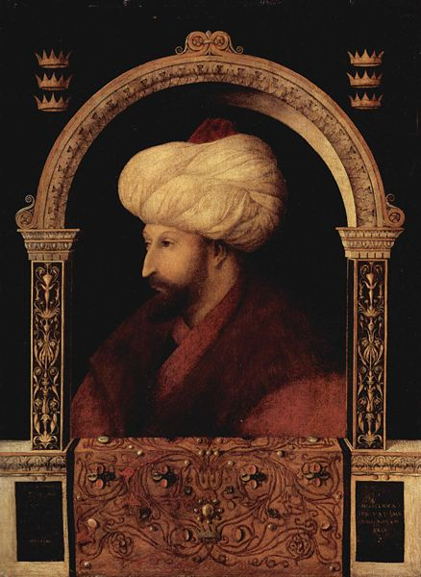
This lucidity is reflective of Mehmed II’s own eclectic interests. He took considerable interest in Christianity (the faith of his mother), protected the Jews, and studied the tenets of the Persian Shiite school (despite the Ottomans being primarily Sunni). Vryonis suggests that Mehmed had almost a “cultural ambiguity” for the outgoing Byzantine culture, as shown by his public display of Islam as the dominant “culture” yet a personal taste for pagan and Christian literature, bureaucrats, statuary, and religious relics. Furthermore, Mehmed II had a strong interest in Western art, evidenced not only in the influence of Italianate decoration and frescoes of his palaces (both original and the Topkapi), but also, more famously, his invitation of Gentile Bellini to his court and subsequent portrait painted of the Sultan (see Figure 4).
This interest in Europe plays an obviously strong role in the development of Constantinople as an Ottoman capital, yet it is unclear as to why Mehmed II was (and many Ottoman Sultans after him were) so focused on the West, as opposed to the East or South. The overall culture emanating from Europe, on an epochal scale, was perhaps very fresh and new to the Turks (Rum Selçuks and later Ottomans) who, in their long migrations from the East had early contact with China and, of course, Persia. A specific disinterest in the East could also be suggested by the many clashes with the Tang and Sung dynasties and especially the pressures of the Mongol Empire prior to the Ottoman Empire’s formation. With knowledge of the Byzantine, Ancient Roman, and Ancient Greek Empires – empires that had geographical possessions that the Turks had not been in familiar contact with - Mehmed II found a new cultural apogee to aspire too.
Figure 4: Mehmed II painted by Gentile Bellini
In terms of relations with the West, it is historically understood that the 1453 fall of Constantinople played some role in the Renaissance of Europe. The scattering of Byzantine scholars and manuscripts - essentially “Classical” knowledge - acted to this effect. Mehmed II, three days after capturing Constantinople, released the ships in port so that “each could go off to its own provinces, bearing a load as to sink. And what sort of load? Luxurious garments, silver, gold, copper, tin vessles, countless books… …Having loaded the wagons with all the books, more than can be counted, they scattered them everywhere in the east and west.” However, it is well noted that Mehmed II’s eclectic interests persuaded him to keep many Greek and Latin manuscripts for himself, notably those of Seneca, Plybius, and Claudius Ptolemy. These and other such texts, including Critobulus’s Historiae, Arrian’s Anabasis, Homer’s Iliad, the Testament of Solomon, and the Greek translation of Buondelmonti’s western travel account allowed him to compare his conquests with those the likes of Alexander the Great (through Arrian’s Anabasis of Alexander), which began to construct a parallel between imperialism and Western history. This is similar notion to Mehmed II’s reported visit to Troy (undoubtedly discovered through Homer’s Iliad) where he asked for the burial place of Achilles and Ajax, apparently in awe of the beauty that they had “such a poet as Homer to sing their praise.”
Mehmed II’s acknowledgement of architecture’s importance in establishing imperial power has already been hinted at but requires further investigation. As Vyronis writes about the three day sack of Constantinople, “the buildings and the walls, however, were his (Mehmed II) and he would not tolerate their alienation, or as in this case, their destruction.” One of Mehmed II’s first official acts was claiming the Hagia Sophia, a place where many Byzantine emperors had been consecrated and crowned, as Islamic space by performing the Muslim prayer. This was not only meant to again legitimize Islam as the cultural power of the Ottoman empire, but within the context of the traditional Byzantine space, the act was meant to establish Islam as the new dominant culture and religion of the former Byzantine empire under Ottoman rule by converting its central icon to Islam.
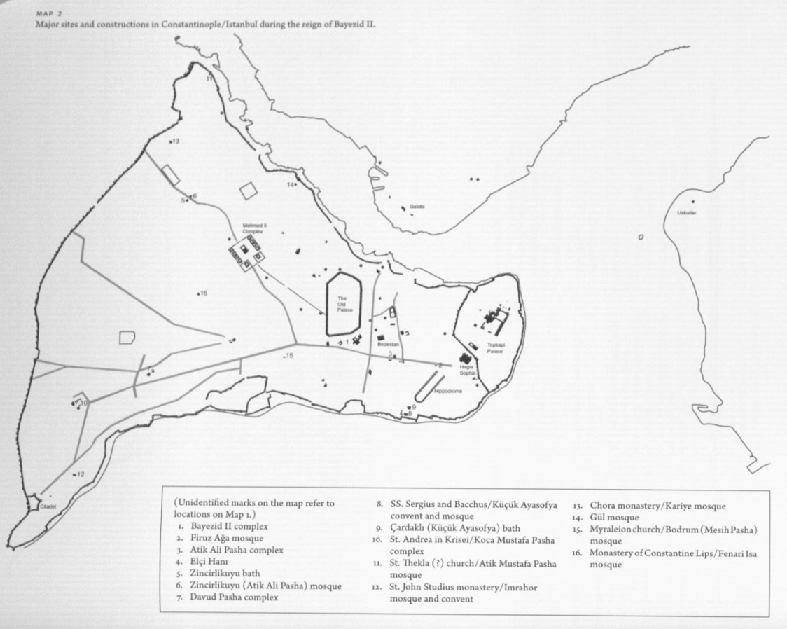
Mehmed II’s further recognition of the connection between imperium and architecture was further realized in his efforts to immediately begin reconstructing the city. Mehmed recognized that to communicate the inheritance of Byzantine’s imperial prestige, a massive program for new and symbolic monuments built on a monumental scale was necessary. However, this program would not be fully realized until Mehmed II’s return from Edirne. Nevertheless, before he left, he set in motion plans to rebuild the Theodosian walls (defending the imperium of Constantinople), convert the Hagia Sophia into a mosque (residence of sanctity), and construct a palace north of the Forum Tauri (residence of imperium). On a return trip to the city, Mehmed II found all three projects completed (See Figure 5).
Overall, the vision and foresight of Sultan Mehmed II played a crucial role in the attempt to legitimize the imperium or imperial power of the burgeoning Ottoman Empire. His eclectic interests helped to establish initial policies that were intended to create a cosmopolitan imperial city equated, in Mehmed II’s mind, with the historic empires generally associated with the west: Ancient Greece and Rome.
Figure 5: Map of Constantinople after Mehmed II siting his initial interventions

Reconstructing Constantinople
“Context” and “agency” have already been examined in the move toward an imperial Ottoman style that recognizes the power architecture has to communicate ideas of culture, progress, and power. The only ingredient remaining for investigation is the “catalyst.” Here, the fall of Constantinople as an event in itself does not serve as a catalyst for the development of imperium, rather the need to rebuild the city serves as the major stimulus, as the city had been decimated to less than half its size by earlier attempts of siezure. As already discussed, Mehmed II’s insight played a crucial role in this development, but it is important to examine a series of specific projects as tangible examples of imperial architecture.
Hagia Sophia had already long been regarded as a symbol of imperial power. Not only did the enormity and monumentality of the structure itself hint at this - a single massive dome creating an open space below - but acting as the central church of the Byzantine Empire provided a connection between Orthodox and Imperial authority. It is no wonder then that Mehmed II’s great grandfather Bayezid I had “nursed the hope of converting the Hagia Sohpia into his royal mosque while contemplating its monumental glory from afar” during an earlier siege and attempt to capture the city. Mehmed II also realized the building’s “imperial prestige,” “monumental magnificence,” and “imposing physical presence” would inevitably stimulate a dialogue with the Byzantine past that “would bind the Ottoman rulers of Constantinople… to the classical imperial tradition.”
Structurally considered, the dome is seen earlier in Ottoman work than the capture of Constantinople, yet the specific structural language used in the Hagia Sophia was not necessarily a part of Ottoman vocabulary. The influence of other Byzantine buildings (those not in Constantinople) played a key role in influencing the early Ottoman mosque, both in terms of domed space and longitudinal or basilican plan, and the history of such can be traced back to the Selçuk conversion of the Basilica of St John of Ephesus into a mosque in 1330 (see Figure 6). The conversion of a building the scale of Hagia Sophia into a mosque, revived the structural system used by the Byzantine architects, making the use of a central dome standard (the early Ottoman mosque had utilized two domes for prayer hall) in Ottoman mosque’s, as well as the notion of semi-domes helping to buttress the main space.
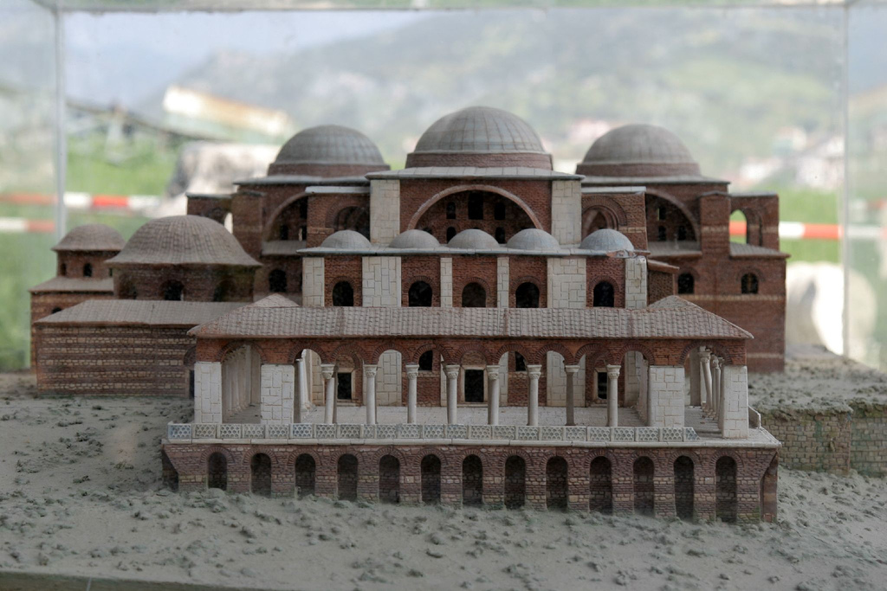
Though the structure of the Hagia Sophia played a key role in creating the monumental imagery of imperium, the physical building itself was not the only factor contributing to the revival of its structural knowledge. In fact, part of the knowledge of the Hagia Sophia can be attributed once again to Mehmed II’s eclectic and western interests. Among the books he kept for his own library after the sack of Constantinople, Mehmed II also owned a copy of the Diegesis, a tenth century text on the erection of Hagia Sophia. The impact of this knowledge figured so importantly in Mehmed II’s understanding of the imperium of Byzantine Constantinople, he had Persian and Turkish translations made within his own lifetime.
Figure 6: Model of Basilica of St. John of Ephesus
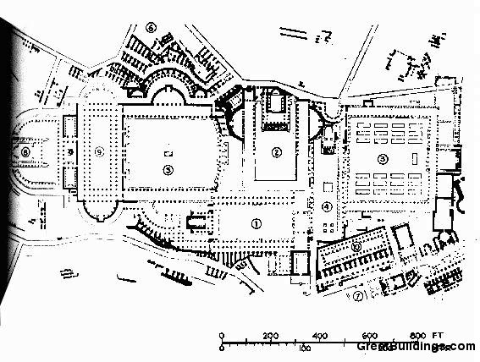
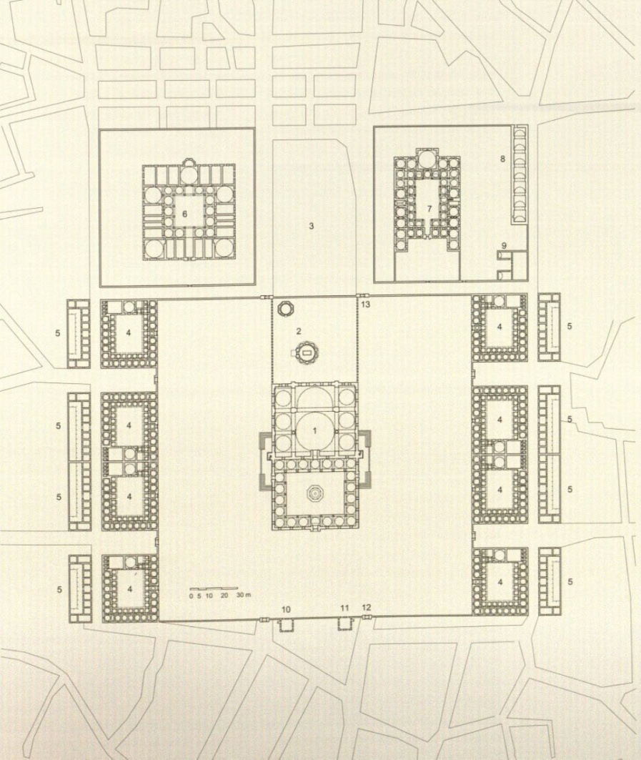
Mehmed II’s fascination with the Diegesis is similar to his fascination with Byzantine Constantinople’s urban fabric the Sultan encountered in the earlier mentioned writings and accounts of Cristoforo Buondelmonti. Thus he chose a site of imperial significance to build the Fatih Külliye (his Mosque complex): Justinian’s Church of Holy Apostles where not only the tomb of Byzantine Emperor Justinian had been located, but also the tomb of his wife Theodora who had served as Empress of the Byzantine Empire (see Figure 7). This külliye was the largest constructed at its time and it incorporates a very functional and centralized layout and that puts emphasis on the centrally located Fatih Mosque as an imperial object. Though not at the same scale as the Hagia Sophia, its use of Hagia Sophia’s structural techniques allowed it a monumentality that rivaled most Renaissance building programs in the West. Despite the innovations in the mosque itself, the only innovations of the larger complex were its size, hyper-functional layout, and the central mosque. The rest of the complex individually employed no architectural experiments. In fact the madrasas were made even simpler and logical, emphasizing even further the innovation of the monumental Fatih Mosque.
Figure 7: Plan of Fatih Külliye
Zooming out, examining the overall plan of the külliye within the context of the city reveals a certain visual affinity to a large, vibrant public realm, similar to a Roman forum (see Figure 8). This may seem like yet another connection between the Ottoman Empire and the imperial Byzantine and Roman past. However, Ulya Vogt-Göknil suggests in Living Architecture: Ottoman, “the quiet courtyards and streets of the Külliye should never be compared with the agora or forum of ancient times.” The Turks did not use the courtyard of the külliye or mosque as a public meeting space, rather, they met in cafes and crowded spaces situated close to walls of the open courtyard spaces. However, the contrast between the quiet space inside the külliye and that of the bustling urban space outside suggests that the approach toward the mosque was even more monumental, its massive silhouette accompanied by the purity and power of silence.
Figure 8: Plan of Roman Forum
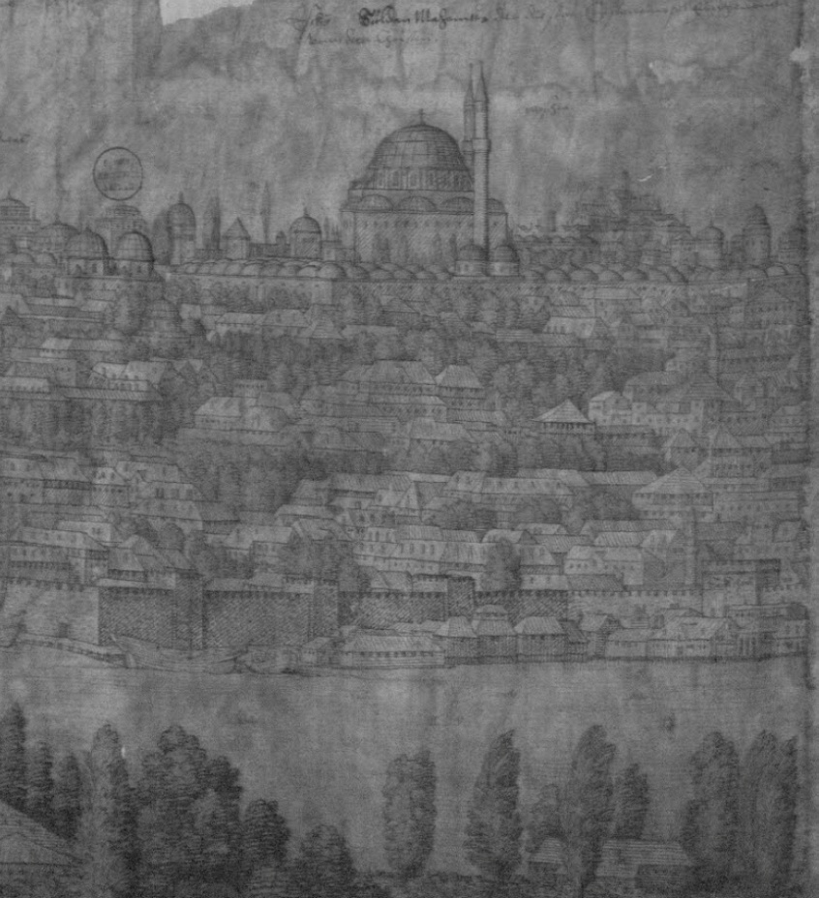
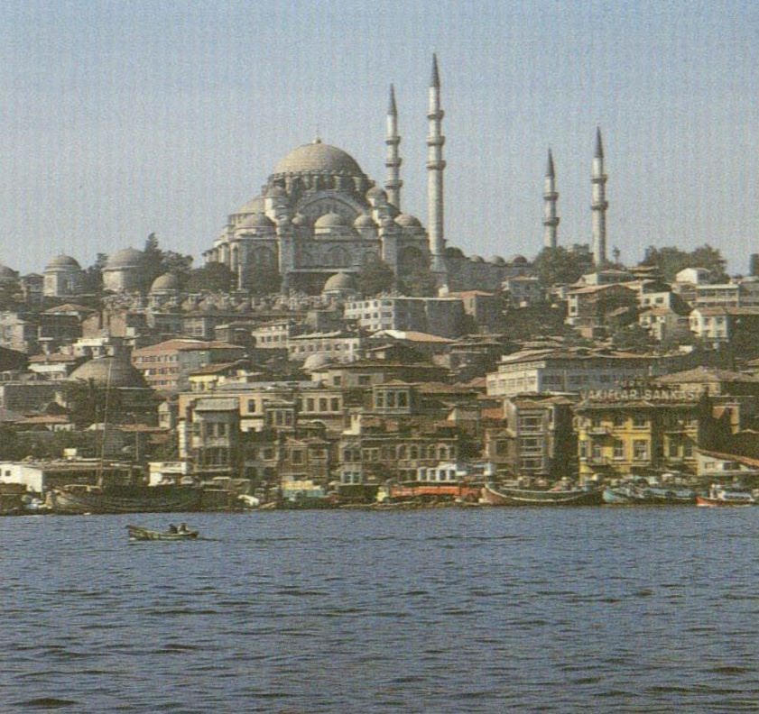
Despite what the contrast may suggest, the Fatih Külliye was neither built merely as a refuge from the city, nor as an Islamic marker on an old imperial site, but rather to commemorate Mehmed II’s capture of the imperial city of Constantinople. In fact, for much of his reign, Mehmed II was the sole patron for architecture, aiding the development of a very specific imperial style. Upon capture of the city, Mehmed II sought to lessen the political influence of old Anatolian aristocracy, forcing many members to disperse to lands where they lost their influence and, later, taking over many pious foundations that had been administered by such families. A singular patron thus made it easy to develop a singular and specific style that aided a specific image of Ottoman Imperium. From that point until 1500 a distinct “imperial” style emerged in the Ottoman Empire “consistent from Sarajevo to Damascus.”
Figure 9: Drawing of Fatih Mosque within city (left) and Süleymaniye (right)
The specific style and imagery of Constantinople’s major architecture also played a crucial role in establishing an image of imperium. The Fatih Külliye was sited specifically on one of the city’s many hills to have a specific image of “authority and power” above the city’s skyline, similar to that of the Hagia Sophia and many other later mosques like the Süleymaniye (see Figure 9). The Topkapi Palace (the sultan’s second palace) played a similar role as well. The sultan’s first palace, begun immediately after the capture of the city and nearly finished by his return from Edirne and built in a very public area on an original Byzantine forum, was not sufficient enough for the size of the empire Mehmed II was envisioning. The site of the new palace, along the Bosphorus, seemed much more suitable. This site was chosen not only for its visual prominence a visually strategic point seen from the Bosphorus, but also for its historical, yet still imperial, significance - that of the ancient acropolis of Byzantium.
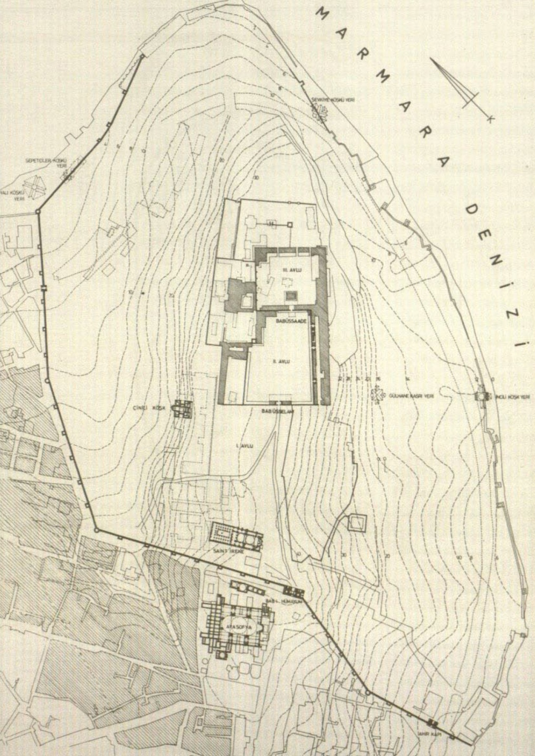
This shift of site also suggests another significant change in the Ottoman understanding of imperium. The site of the Topkapi Palace, suggests a move from a very prominent and visible site on an ancient forum and near the hippodrome, to a very secluded site behind the Hagia Sophia (see Figure 10). This was reflected in a similar shift of attitudes and court protocol. The anger and frustration many theologians and jurists expressed toward the sultan in meeting with him suggests an intimacy and familiarity in their relationship. However, in later years, Mehmed II was more reclusive and protocol was structured and antiseptic. The establishment of kanunname outlined and governed the hierarchy of each official’s relationship to the sultan, in effect permitting only a few select officials to actually address the sultan.
Figure 10: Plan of Topkapi Palace
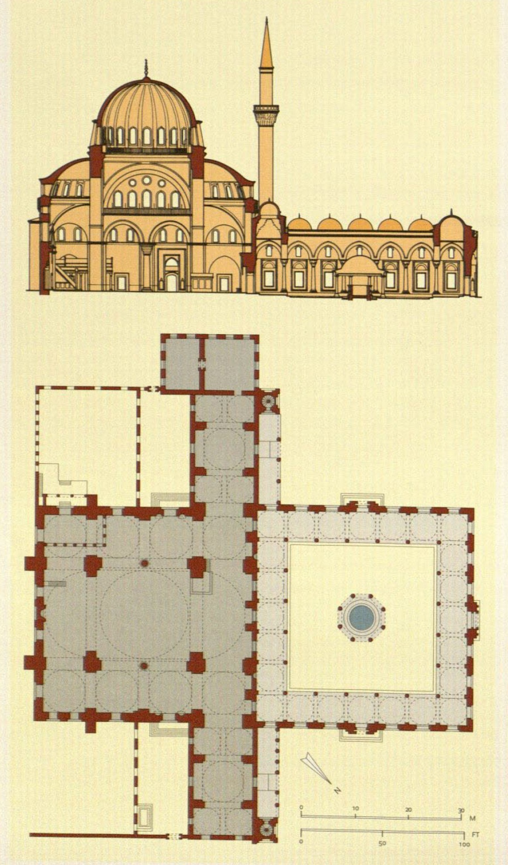
Mehmed II eventually passed on, and the task of rebuilding Constantinople and Ottoman imperium, though significantly established under the Fatih’s reign, was not quite complete. Though reversing some of the policies of his father, Beyazid II shared Mehmed II’s interest in the West, requesting works in Constantinople from the like of Leonardo Da Vinci and Michelangelo (though such works never occurred). However, Beyazid II’s chief architect Hayrettin was able to achieve a singularly classical Ottoman style in the design of the Bayezid II Mosque in Constantinople. Here, Hayrettin established a model for a mosque based on the structural language of the Hagia Sohpia (see Figure 11). In this mosque, the prayer hall is no longer oblong like the still referential Mehmed II mosque, but rather square, essentially more coherent and rigorously geometric. The space created was a unified undivided interior, and the general effect was that of an unmoving mass: the solidity of a single element – the solidity of a single empire. From this point on, with only a few exceptions, the Byzantine influence tended to prevail.
Figure 11: Bayezid II Mosque
Ultimately, the need to rebuild Constantinople as an imperial city acted as a catalyst for the development of an imperial style. The conversion of mosques, the construction of külliye, and the location and construction of an imperial palace all helped to establish imperial ties to the Byzantine Empire as well as begin to develop a unique pattern for the Ottoman Empire. It was at this point that the Ottoman Empire had entered its classical age, ushering in a golden age that would exceed the achievements of the Byzantines, establishing the Ottoman authority not only internally, but to the rest of the world as well.

Ushering in a Golden Age
Essentially, much of western architecture history from medieval to pre-modern is told in churches, it only makes sense that one can learn a great deal from mosques in Ottoman architecture history. However, the context of the Ottoman capture and rebuilding of Constantinople provide a specific context that aided in the efforts of the fledgling empire to establish its imperial authority. Such imperium was achieved via a notion of inheritance of empire passed on from generation to generation – from Selçuk to Ottoman, the foresight of the Fatih sultan himself - Mehmed II’s acknowledgement of architecture’s role in communicating imperium, and the catalyst of the need to rebuild a decimated city into an imperial capital that would permanently establish the Ottoman Empire’s imperial authority not only internally, but also as a (if not the) dominant empire in the world for several centuries.
Under Selim I, the Ottoman Empire expanded to encompass Cairo and Mecca, assumed the title of Caliph, and made the sultans the heads of the Muslim community. His conquests were numerable, but imperial architecture was limited. His son Süleyman, however, not only expanded the Ottoman sway even further, but was also one of the last sultans to be obsessed with the connection between his empire, and that of Justinian’s. Süleyman was the sultan who initially established the mythical and imperial genealogical connection between the Ottoman Sultans and Justinian, in an attempt to draw a connection to the most ancient of religious rulers: Solomon. Therefore, the adaptation of the Hagia Sophia as a “model” for mosque architecture helps to establish this connection, as in Justinian’s time, the Hagia Sophia was seen as an analog itself to Solomon’s Temple in Jerusalem.
However, the Hagia Sophia “was never a ‘model’ in the accepted sense of the word.” The Ottomans sought to not just match its imperial grandeur, but to improve upon it with their own invention. Such an effect was eventually achieved by the famed Sinan, Süleyman’s royal architect. In his design for the Süleymaniye, Sinan does not attempt to surpass the size of the Hagia Sophia (though he was capable of doing so evidenced by his work at Edirne). Rather, Sinan develops a method to remove intermediary supports to provide for a more complete fusion between nave and aisles. Futhermore, the Süleymaniye is much more luminous, a striking contrast from the “shadowy mystery” of Hagia Sophia’s interior. Examining the mosque in the context of its larger külliye and city shows an even further development of the individual object of the mosque. Though not as set back with open space as the Mehmed II mosque and külliye, its location in the city establishes a certain authority and “is one of the defining features of Istanbul.”
Sinan went on to create other great masterpieces and works not exclusively religious in nature. However, he finalized an imperial architecture language that’s pattern was established in the first decades after the capture of Constantinople. The fabric of the city allowed an everyday encounter with imperial architecture that spurred architects to achieve similar grandeur in their work. The rule of Süleyman and the work of Sinan represent the height of such a specific imperial ideal and style, a Golden Age of Ottoman architecture possible only through the capture and subsequent rebuilding of Constantinople as the icon of Ottoman Imperium.

Bibilography:
Ahunbay, Metin and Zeyned Ahunbay. “Structural Influence of Hagia Sophia on Ottoman Mosque Architecture” in Hagia Sophia From the Age of Justinian to the Present. Robert Mark and Ahmet S. Çakmak, ed. Australia: Cambridge University Press, 1992.
Faroqhi, Suraiya. Subjects of the Sultans. New York: I.B. Tauris, 2000.
Goodwin, Godfrey. A History of Ottoman Architecture. Baltimore: Johns Hopkins Press, 1971.
Goodwin, Godfrey. Ottoman Turkey. London: Scorpion Publications, 1977.
Kafescioglu, Çigdem. Constantinopolis/Istanbul: Cultural Encounter, Imperial Vision, and the Construction of the Ottoman Capital. Pennsylvania: Penn State University Press, 2009.
Lewis, Raphaela. Everyday Life in Ottoman Turkey. London: B.T. Batsford, 1971.
Necipoglu, Gülru. Architecture, Ceremonial, and Power: The Topkapi Palace in the Fifteenth and Sixteenth Centuries. Cambridge, Massachusetts: MIT Press, 1991.
Stierlin, Henri. Turkey: From the Selçuks to the Ottomans. Köln: Taschen, 1998.
Vogt-Göknil, Ulya. Living Architecture: Ottoman. New York: Grosset and Dunlap, 1966.
Vryonis, Speros, Jr. “Byzantine Constantinople and Ottoman Istanbul” in Ottoman City and Its Parts. Irene Bierman, Rifa’at A. Abou-el-haj, Donald Preziosi, ed. New York: Aristide D. Caratzas, 1991.
Yiannias, John, ed. The Byzantine Tradition After the Fall of Constantinople. Charlottesville: University Press of Virginia, 1991.

Speros Vryonis, Jr., “Byzantine Constantinople and Ottoman Istanbul”, in Ottoman City and Its Parts, Irene Bierman, Rifa’at A. abou-el-haj, Donald preziosi, ed. New York: Aristide D. Caratzas, 1991, pg. 29.
Henri Stierlin, Turkey: From the Selçuks to the Ottomans, Köln: Taschen, 1998, pg. 131. Eventually, this notion would be played upon to a literal extent: a genealogical tie between Süleyman and Justinian was created to help legitimate the Ottoman Empire. Süleyman was akin to “Solomon” in the Islamic tradition, and Justinian’s Hagia Sophia was itself seen as an analogon of Solomon’s Temple in Jerusalem.
Stierlin, Turkey, 8.
Suraiya Faroqhi, Subjects of the Sultans, New York: I.B. Tauris, 2000, pg. 29.
Stierlin, Turkey, 79.
Ibid., 15.
Stierlin, Turkey, 57.
Ibid., 37, 44.
Ulya Vogt-Göknil, Living Architecture: Ottoman, New York: Grosset and Dunlap, 1966, pg. 47.
Stierlin, Turkey, 86.
Vogt-Göknil, Living Architeture, 90.
Stierlin, Turkey, 92.
Stierlin, Turkey, 100.
Vyronis Jr., Ottoman City and Its Parts, 38.
Ibid., 20.
Spierlin, Turkey, 100.
Vyronis Jr., Ottoman City and Its Parts, 40. Ironically, Mehmed II’s son would use the Byzantine relics his father had collected as diplomatic bargaining pieces with the West, evidence of the distinctness of Mehmed II’s personality.
Faroqhi, Subjects of the Sultans, 31.
Spierlin, Turkey, 9.
Ibid.
Vyronis Jr., Ottoman City and Its Parts, 37.
Spierlin, Turkey, 100.
Vyronis Jr., Ottoman City and Its Parts, 39. This tie between the West and imperialism will be echoed later through the choice of spaces in the reconstruction of Constantinople.
Ibid., 29.
Spierlin, Turkey, 100.
Vyronis Jr., Ottoman City and Its Parts, 29.
Mentioned in the introduction to “Mehmed the Modern” as key ingredients in the development of Ottoman architecture: Context, Catalyst, and Key Player(s).
Metin Ahunbay and Zeyned Ahunbay, “Structural Influence of Hagia Sophia on Ottoman Mosque Architecture”, in Hagia Sophia From the Age of Justinian to the Present, Robert Mark and Ahmet S. Çakmak, ed. Australia: Cambridge University Press, 1992, pg. 196.
Ibid. It is important to note here that Mehmed II kept the name of the city as Constantinople (not Istanbul) to further relate this connection with imperial history. Its official name of Ķoşţantiniyye was used in Ottoman imperial documents and coins.
Spierlin, Turkey, 96.
Ibid., 85.
Ahunbay, Hagia Sophia, 94.
Vyronis Jr., Ottoman City and Its Parts, 39.
Vogt-Göknil, Living Architecture, 51.
Ibid., 62.
Spierlin, Turkey, 100.
Vogt-Göknil, Living Architecture, 52. The mosque itself was not quite as innovative as it could have been. The Hagia Sophia model was not followed strictly in order to create a more oblong and traditional prayer hall. Removal of the front semi-dome caused an eventual collapse.
Vogt-Göknil, Living Architecture, 61.
Faroqhi, Subjects of the Sultans, 31. Here, again, Mehmed II’s son Bayezid II would eventually counteract his father’s policies.
Çigdem Kafescioglu, Constantinopolis/Istanbul: Cultural Encounter, Imperial Vision, and the Construction of the Ottoman Capital, Pennsylvania: Penn State University Press, 2009, pg. 75.
Spierlin, Turkey, 131.
Gülru Necipoglu, Architecture, Ceremonial, and Power: The Topkapi Palace in the Fifteenth and Sixteenth Centuries, Cambridge, Massachusetts: MIT Press, 1991, pg. 4.
Faroqhi, Subjects of the Sultans, 31.
Necipoglu, Architecture, Ceremonial, and Power, 16.
Spierlin, Turkey, 99.
Ibid., 111. One could argue that the two “transepts” do create an oblong prayer hall of traditional style, but the overall impression is a square prayer hall, not to mention to very cathedral-like plan.
Vogt-Göknil, Living Architecture, 96.
Spierlin, Turkey, 111.
Spierlin, Turkey, 115.
Spierlin, Turkey, 131.
Vogt-Göknil, Living Architecture, 93.
Spierlin, Turkey, 130.
Ibid., 131.

